**Institute of Technology Tralee**

**BSc. in Computing with Specialism (Group 2) - Year 1**

**Continuous Assessment #2**

**Date: 2/12/13**

**Time: 1 – 3 p.m.**

**Introduction to Programming**

**Instructions:** Attempt the following question. You should use the JCreator IDE for coding. When you are finished you must print out your code for correction.

**________________________________________________________**

**Q1.**

A program is required that will read in a sentence from the user which is terminated with a full-stop or exclamation mark. The sentence will then be analysed to determine

* The total number of characters it contains (**excluding** the full-stop/exclamation mark)
* The number of characters that are vowels (uppercase or lowercase)
* The number of characters that are digits
* The number of characters that are odd numbers
* The number of times that the same character occurs consecutively (for this you can ignore case differences)

Using the test values as indicated in the screen shots below, the program should give you **exactly** the following output when it runs, including any banners, blank lines, tabs etc.

Also note that there will be a few marks awarded for having a **single-line comment** and **a meaningful multi-line comment at the top of the program**.

**Sample Screen Shots**

**Run 1 – The sentence is entered, terminated with an exclamation mark, analysed and then the stats appear**

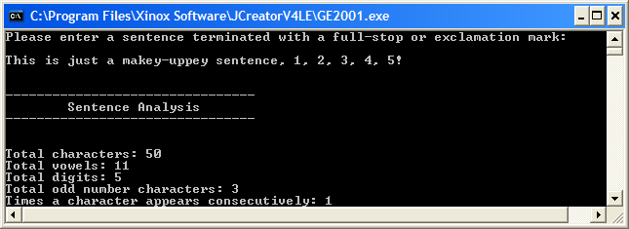

**Run 2 – This time the sentence is terminated with a full-stop**

